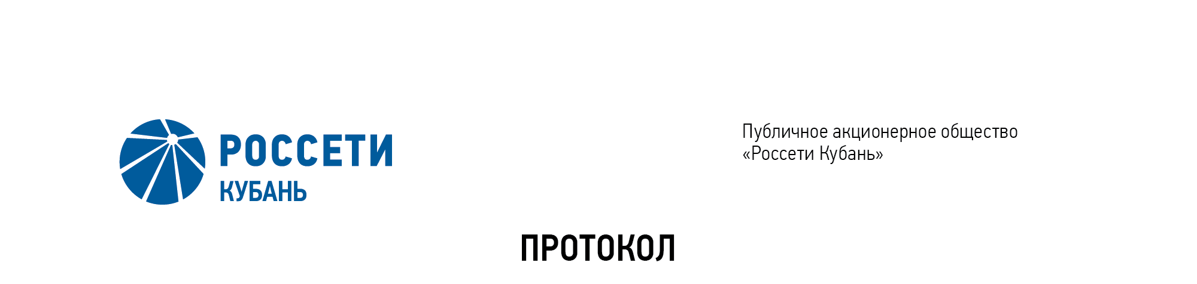
Minutes of the Meeting of the Board of Directors No. 416/2021

of the Public Joint Stock Company

Rosseti Kuban (PJSC Rosseti Kuban)
Date of Meeting | January 14, 2021
Form of Meeting: | Absentee voting (by questionnaire)
Location of summing up the voting results: | room 202, building 2, 2А Stavropolskaya Str., Krasnodar (for postage to the Corporate Secretary of PJSC Rosseti Kuban)
Date on which the minutes were drawn up: | January 14, 2021
Members of the Board of Directors: 11 persons
Members of the Board of Directors were submitted the checklists: Gavrilov A.I. (Chairman of the Board of Directors), Alyushenko I.D., Varvarin A.V., Guryanov D.L., Logatkin A.V., Medvedev M.V., Sergeev S.V., Terekhov I.A., Shagina I.A., Yavorskiy V.K.
Members of the Board of Directors were not submitted the checklists: Varseev V. V.
In accordance with the Clause 7.3 “Regulations on the Board of Directors of Public Joint Stock Company of Power Industry and Electrification of Kuban” (passed by the decision of the Annual General Meeting of Shareholders of PJSC Kubanenergo, Minutes No. 43 of May 29, 2020) at least half of the number of elected members of the Board of Directors of the Company constitutes a quorum for a meeting of the Board of Directors.
A quorum is present.

Agenda of the meeting of the Board of Directors:

1. On approval of candidacies for the separate positions of the executive branch of the Company, elected by the Company’s Board of Directors.

Item No. 1: On approval of candidacies for the separate positions of the executive branch of the Company, elected by the Company’s Board of Directors.
The following solution was offered:
To agree on the candidacy of Statuev Vladislav Andreevich for the position of Deputy General Director for Security of PJSC Rosseti Kuban with a term of office until August 17, 2022 inclusive.
The results of voting:
Gavrilov A.I. | - | “FOR” | Medvedev M.V. | - | “FOR”
Alyushenko I. D | - | “FOR” | Sergeev S.V. | - | “FOR”
Varvarin А.V. | - | “FOR” | Terekhov I.A. | - | “FOR”
Guryanov D.L. | - | “FOR” | Shagina I.A. | - | “FOR”
Logatkin A.V. | - | “FOR” | Yavorskiy V.К. | - | “FOR”
Thus, regarding the first Agenda Item of the meeting, the resolution was adopted unanimously by the Board of Directors participating in the meeting.

Chairman of the Board of Directors А.I. Gavrilov

Corporate Secretary O.V. Russu

